**REGex Software Services**

**Java Full Stack Development Program**

Registration I'd:  **IIPRSS1404**

Name: **Shanmukh Subhash Kumbhar**

# Subject: Assignment 19 - #Collection

a 2021 **Core Java Session 19 Assignments**

**Assignment - 1:**

Write a java program and represent the fallowing elements in **HashSet** object. **Java, Angular, ReactJS, JavaScript, Python**.

Iterate one by one element using **for-each loop**.

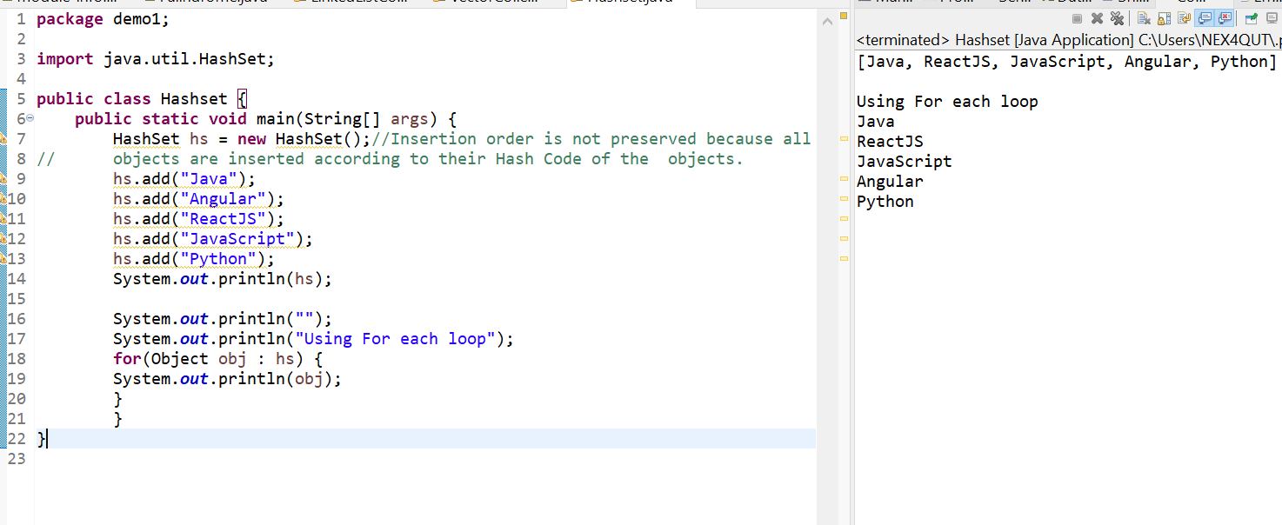**Assignment - 2:**

Write a java program and represent the fallowing elements in **LinkedHashSet** object. **Java, Angular, ReactJS, JavaScript, Python**.

Iterate one by one element using **for-each loop**.

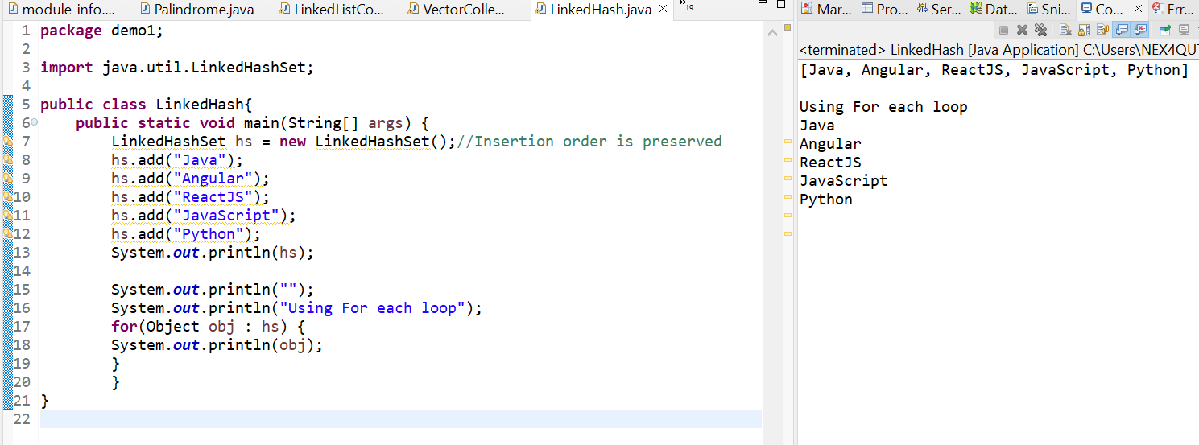

**Assignment - 3:**

Write a java program and represent the fallowing elements in **TreeSet** object.

**Java, Angular, ReactJS, JavaScript, Python**.

Iterate one by one element using **for-each loop**.

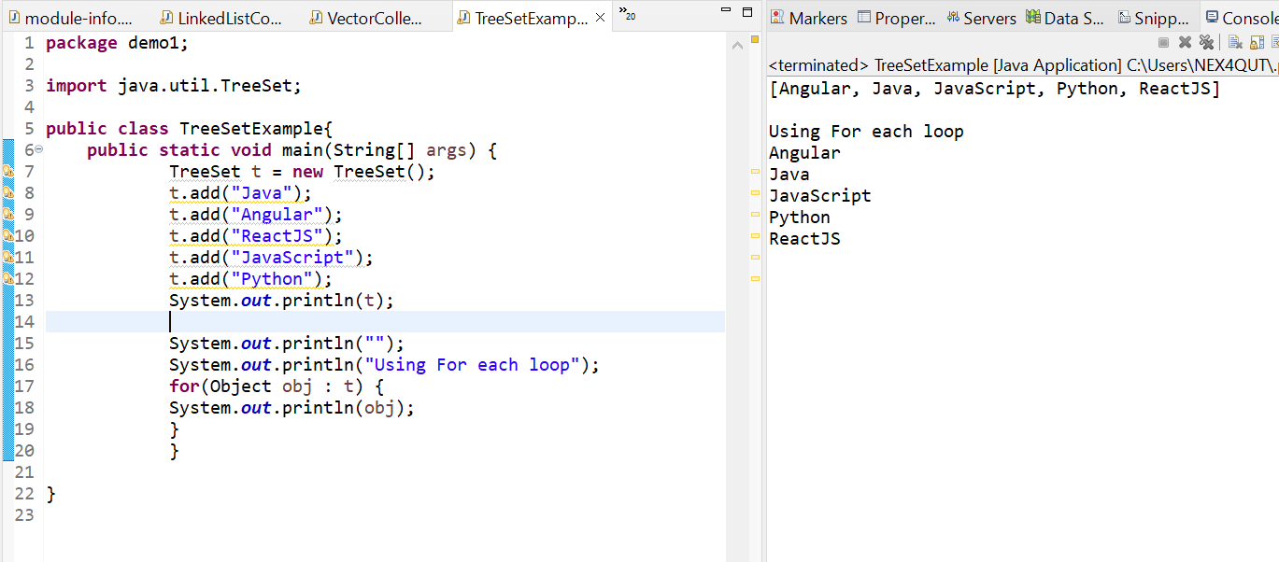

**Assignment - 4:**

Generate a **Product** class with properties like **productid, productName, productPrice**; Write a java program and represent the fallowing 5 product objects in **TreeSet** object. And implement the fallowing comparators and use them in TreeSet.

ProductIdComparator,

ProductNameComparator,

ProductPriceComparator.



